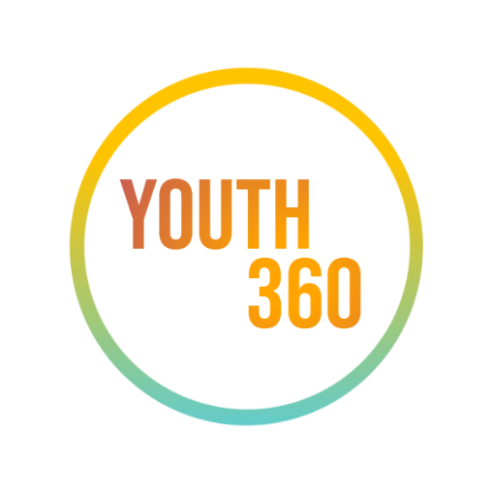
STUDENT RECOMMENDATION FORM

Youth 360:
Cleveland Rape Crisis Center’s
Youth Advisory & Leadership Program

Cleveland Rape Crisis Center’s Youth Advisory & Leadership Alliance, or Youth 360 for short, is a group where young leaders gain skills to become change agents and activists in their community.

In addition to leadership development and character building, Ambassadors (grades 6-12) will help inform and provide insight toward:

- youth initiatives and educational content
- creation and development of CRCC mobile application
- recruitment and training objectives for other youth ambassadors within CRCC’s 4-county service region

Youth 360 members will also get the chance to learn about related topics, such as oppression, gender identity, media literacy, and comprehensive sex education. Participants will build skills like: program design, community activism, team building, peer communication and leadership!

We do not require a certain GPA, but to be successful in this program, they must have basic skills like timely attendance, works well with others, accepts direction, and is eager to learn.

Please provide your candid input on this applicant to the best of your ability. Provide any specific details you can. Thank you for your time!

Your name: Click or tap here to enter text. Title/Position: Click or tap here to enter text.

Student’s Name: Click or tap here to enter text. How do you know him, her or them? Click or tap here to enter text.
Daytime Phone: Click or tap here to enter text. Email: Click or tap here to enter text.

Please tell us your impression of the student’s motivation to learn, ability to take direction, ability to get along with others, attendance pattern and potential for community activism. Click or tap here to enter text.

Are you willing to talk with this student once a month about his/her involvement in Youth 360? Click or tap here to enter text.

Signature: _________________________________ Date:_________________________

Please submit by 5:00 pm on February 26th, 2021 to:
SharonK@clevelandrcc.org Attn: Youth 360 (Student Full Name) Recommendation Letter

